ESP32 Remote Communication

- Wi-Fi include HTTP requests, where the ESP32 sends or receives data from a web server;
- WebSockets, which allow two-way live communication;
- UDP or TCP sockets, which are lower-level but flexible;
- A very crude method is an HTTP push message, where the ESP32 sends a simple web request like: http://server-address/update?value=23
- Bluetooth/BLE, if Wi-Fi is not needed or as a backup or direct close range access

MQTT
MQTT (Message Queuing Telemetry Transport) is a lightweight messaging system often used with devices like the ESP32.
Instead of devices talking directly to each other, they connect to a broker.
A device can publish a message to a topic, such as home/temperature, and other devices can subscribe to that topic to receive updates. This makes MQTT useful for sensor data, remote control, and IoT projects because it is simple, fast, and works well over Wi-Fi.
In PubSubClient library, the ESP32 connects to Wi-Fi, connects to the MQTT broker, then publish() sends data and subscribe() listens for commands.
A simple version:
- Publisher = sends the message.
- Broker = the middle server that passes messages around.
- Subscriber = receives the message.

Test program with MQTT:
Go to: https://www.hivemq.com/demos/websocket-client/
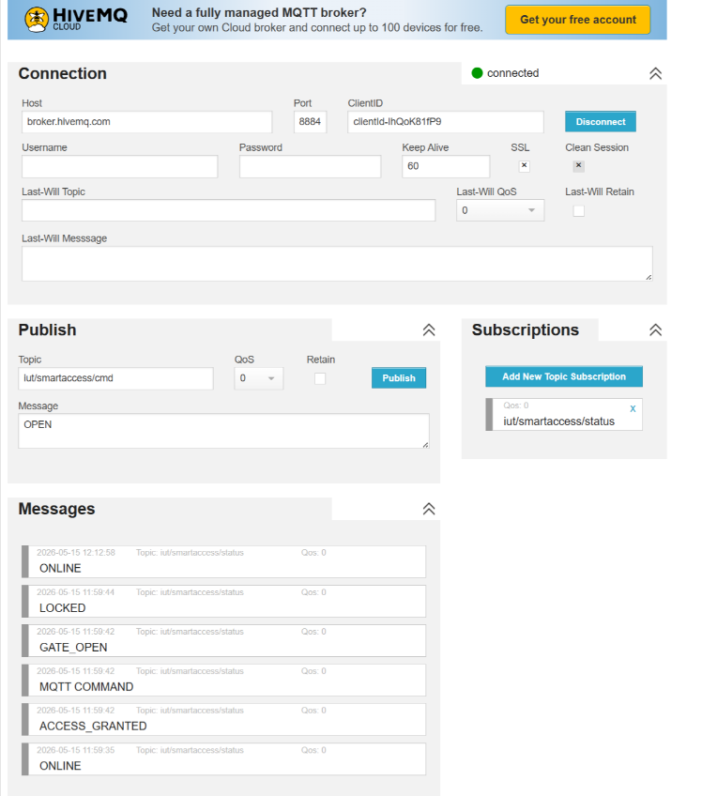
- Connection:
Host: broker.hivemq.com
Port: 8884
Click Connect

- Subscriptions:
Add New Topic:
iut/smartaccess/status
- Publish:
Topic: iut/smartaccess/cmd
Message: OPEN
Click Publish and
see your Wokwi diagram

